Data Science Class 1

September 25, 2018

* Welcome to Data Science
* Instructors
  + Steven Longstreet – lead instructor
  + John Whitesell – instructor assistant
  + Ed Salinas – instructor assistant
* What is data science
  + Artificial intelligence
  + Machine learning
  + Data science is the application of machine learning to solve real world problems
    - Capable of creating immense value in everyday life
  + 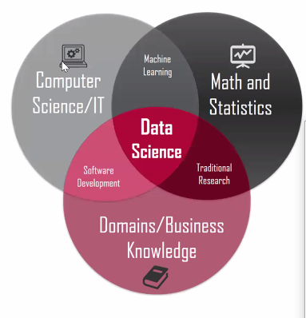
  + There is no definition and no roadmap while demand increases
  + Data science is the practice of
    - Acquiring, organizing and delivering complex data
    - Discovering relationships and anomalies among variables
    - Building and deploying machine learning models
    - And synthesizing data to influence decisions
  + Data science is the 4th industrial revolution
    - Big data, immense advances in processing power, machine learning and data science are at the forefront of an explosive new chapter in human history
* Overview of the data science workflow
  + Frame – develop a hypothesis-driven approach to your analysis
  + Prepare – Select, import, explore, and clean your data
  + Analyze – Structure, visualize, and complete your analysis
  + Interpret – Derive recommendation and business decisions from your data
  + Communicate – Present (edited) insights from your data to different audiences